ML Project: Classification of Turkish Housing Prices

1. Project Objective
- Predict housing price tiers (Low, Medium, High) in Turkey.
- Help in marketing segmentation and mortgage eligibility decisions.
- Convert continuous price (fiyat) into three classes for classification.

2. Dataset Overview
- File: Processed_Turkish_House_Sales_2025.csv
- Key Features:
satici_tip → Seller Type
- Metrekare → Square Meters
- Oda_Sayisi → Number of Rooms
- il, Ilce, Mahalle → City, District, Neighborhood
- Tarih → Listing Date
- fiyat → House Price (Target variable, converted to price_class)

3. Data Preprocessing
- Price Tiering:
- 0 → Low (<3,000,000 TRY)
- 1 → Medium (3,000,000–6,000,000 TRY)
- 2 → High (>6,000,000 TRY)
- Categorical Encoding: One-hot encoding for all categorical features.
- Train/Test Split: 80% train, 20% test (random_state=42).

4. Exploratory Data Analysis (EDA)
- Price distribution skewed towards low-priced houses.
- Seller type (satici_tip) affects prices: agent listings tend to be higher.
Plots:
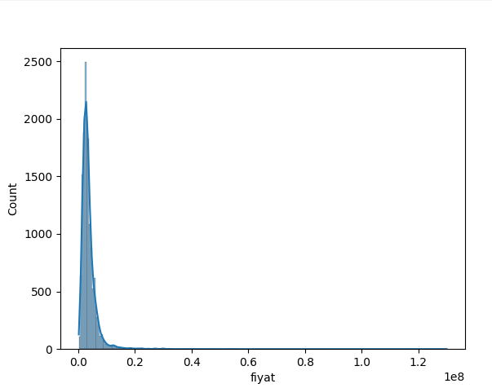
- Histogram of prices

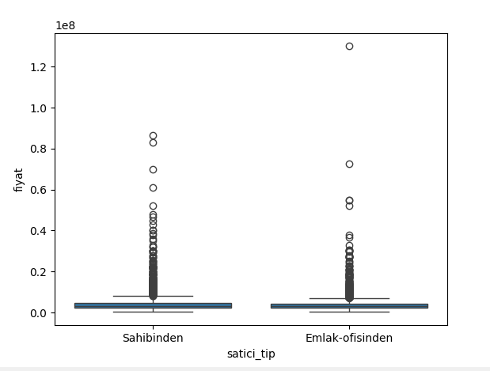
- Boxplot of seller type vs price

5. Model Training
- Algorithm: Random Forest Classifier (n_estimators=100).
- Trained on encoded features to predict price class.
- Random Forest handles categorical variables and is robust for tabular data.

6. Model Evaluation
- Accuracy: 0.72
- Classification Report: Shows precision, recall, and F1-score per class.
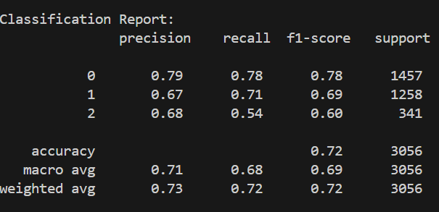

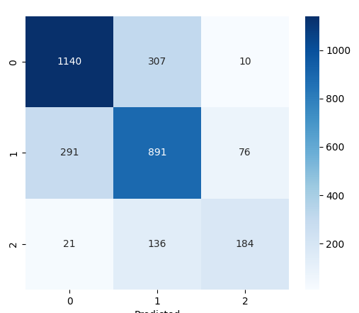
- Confusion Matrix: Visualizes correct and incorrect predictions for each class.
- Observations:
- Low-price houses predicted most accurately.
- Medium and High classes sometimes misclassified due to overlapping features.

7. Sample Prediction
- Sample House Features: { 'Metrekare': 100, 'Oda_Sayisi': 3, 'satici_tip_Agent': 1, … }
- Predicted Price Class: 0 → Low
- Probability Vector: [0.9875, 0.0125, 0.0] → Model confidence for each class.

8. Limitations
- Medium and High price classes are less balanced → reduces accuracy.
- Listing date (Tarih) could be better used (seasonality trends).
- More advanced models (XGBoost, HistGradientBoosting) could improve performance.

